
Connect
Advent-Christmas 2025
The Magazine of the Parishes of the trunch group

A special large issue containing –
- Advent and Christmas services
- Worshipping God in art and poetry
- Books for Advent and Christmas
- Seasonal reflections
- Advent and Ecochurch 2025

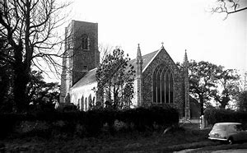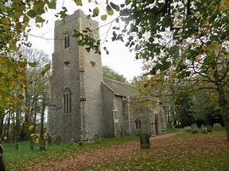
Bradfield Gimingham
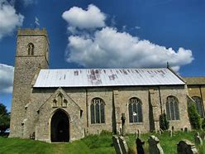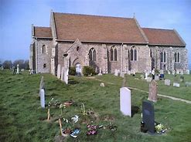
knapton mundesley
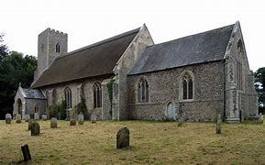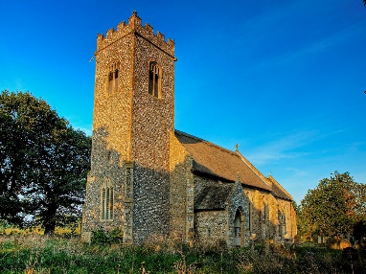
Paston swafield
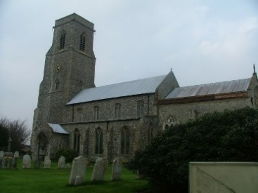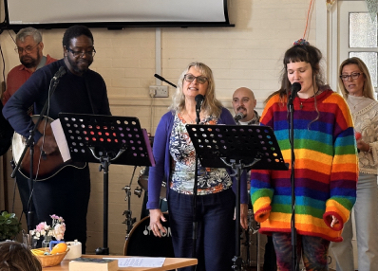
Trunch café church
Hello Everyone,


I can hardly believe that I am about to spend my second Christmas with you. To be honest the last one was a bit of blur, with everyone seemingly knowing exactly what the traditions were apart from me! It was nevertheless rather wonderful to be carried along by events from the Taverham Brass Band, community carol services, school visits, mince pies, mulled wine, crib services, Christingles and very many Christmas lunches to the Midnight Mass at Mundesley and Christmas Day Eucharist at Trunch, followed by the final Christmas lunch at the Community Hub. This year looks shaping up to be much the same (just as traditions should be) and I am very much looking forward to it.
And wonderfully, behind the business of our preparations and celebrations there is the constant echo of that beautiful hymn; O Come O Come Emmanuel (See a review of a book about it later in the magazine and click here for more information and to have a listen!)
The seven verses of the hymn echo the seven O antiphons, which are the short chants that form part of traditional evensong in the days leading up to Christmas Day. They are each worthy of a whole Connect magazine! But during Advent this year, I want to reflect on the yearning expressed in the first line of the song and the last of the antiphons, O Come Emmanuel.
Emmanuel or Immanuel refers to one of the names given to God in the Old Testament and means ‘God with us’. The Christian understandings of Christmas centre around the idea that in and through the birth of Jesus, God is incarnated (made flesh) and comes to be among his people, something that was foretold in Isaiah 7.14. As we journey through Advent, we might perhaps remember that by the Holy Spirit God is indeed with us, in our hearts, minds and souls, in fellowship with one another, and indeed in all that will meet - including in the shopping queues!
May God bless you richly in the season of Advent.
Sally

Editorial

Each year the Church of England commissions and publishes a small booklet to celebrate Christmas, with seasonal reflections on biblical themes. Sometimes these booklets are given away at carol services, especially to families who perhaps only come to church occasionally, in the hope that some will return to explore the deeper meanings of Christianity in the new year. I especially like this year’s offering: Twelve Joys of Christmas by Nick Papadopulos, Dean of Salisbury. It describes traditional joys – the unashamed pleasure of special food, healthy walks, pantomimes, the smell of pine needles and so on. Nostalgia for times past? Perhaps – but why not? Joys which do not involve TV or computer games, at least for a few days, are no bad thing. And the booklet does not forget the fundamental reason for our festival – the coming of Jesus Christ into a bleak and potentially hostile world.

This issue of Connect magazine deliberately takes a similarly reflective approach to the traditions of these final days of the year. We begin with the solemnity of dark Advent, which gradually materialises into a festival of light and joy. This issue marks and celebrates Christian art, poetry and books – some familiar, some unfamiliar and innovative. I believe this is important, for the way in which paintings and literature, indeed all works of imagination, can deepen our understanding of scripture is a significant but often neglected aspect of Christian life. I hope therefore that you find fresh food for thought in this issue, as we prepare to celebrate the momentous coming of Jesus Christ into our world.
4
Art for Advent
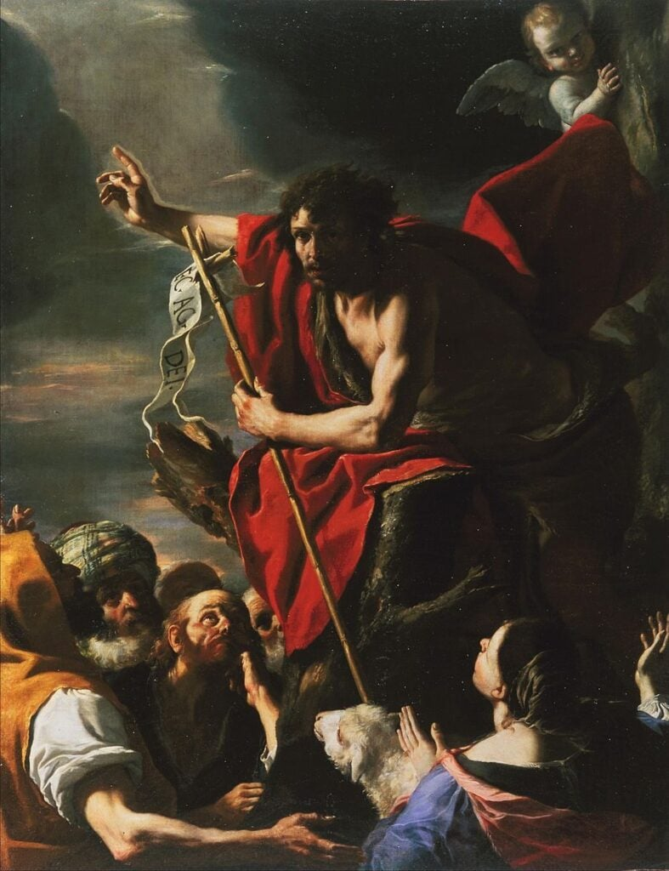
Anon: The Preaching of John the Baptist
Each year in Advent we think about the message of John the Baptist, the great forerunner of Jesus, often described as the last Old Testament prophet. He is a formidable character, a fierce man, but one who is utterly integral to the Christian story. We know a lot about him. He is in all the gospels, and he features in independent Roman histories of the first century. He was spirited child according to Luke, and he became a spirited and courageous man. But I suggest he was difficult company for conventional people. He did not dress to impress; he ate locusts and wild honey; and he lived in the wilderness. The gospels attribute speeches to John that are not exactly tactful. And he had the effrontery to criticise King Herod’s morality to his face, something that eventually cost him his life. John told the large crowds that gathered to hear him that the
5
kingdom of heaven has come near (note the present tense). He told them to repent, and bear fruit worthy of that repentance. In Luke’s version of John the Baptist’s teaching, more practical advice is added, since the crowds asked him what they must do. ‘Whoever has two coats must share with anyone who has none; and whoever has food must do likewise.’ Tax collectors and soldiers were told to be honest and avoid corruption or extortion. Charity and honesty – none of this is especially difficult, but these again are ingredients for our Christmas preparation.

A poem for Advent
Creator and created by Alice Meynell
No sudden thing of glory and fear
Was the Lord’s coming; but the dear
Slow Nature days followed each other
To form the Saviour from his Mother
One of the children of the year.
The earth, the rain, received the trust.
The sun and dews, to frame the Just,
He drew His daily life from these,
According to his own decrees
Who makes man from the fertile dust.

Sweet summer and the winter wild,
These brought Him forth, the Undefiled.
The happy spring renewed again
His daily bread, the growing grain
The food and raiment of the Child.

6
This poem by the Catholic writer, Alice Meynell, has an interesting theme. Her idea is that, if Advent is a time of waiting for the incarnation, then we surely have a paradox. God, the creator of our universe, is about to create a baby, who is God himself. He is both Creator and created. Although he came like every other baby and his childhood was just like any other child, he himself created our universe from cosmic dust. The whole poem stresses the reality of the incarnation, but underlines that here is an infinitely powerful God, who submits himself to the laws of nature he created. The mysteries of Advent are never ending.

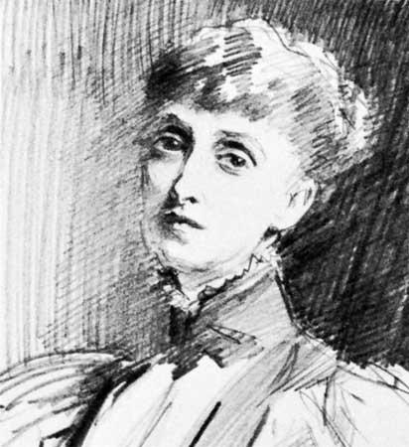
Alice Meynell (1847-1922)

7
New Books for Advent

O Come Emmanuel: Reflections on the Advent Antiphons
Jane Williams and others, Church House Publishing, £9.99
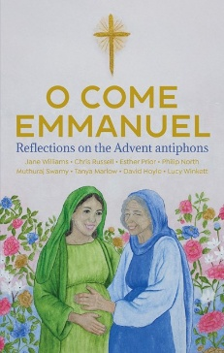
One of the enduring notes of the Advent season is the way that the liturgical mood changes after 17 December, principally because the introduction of the Advent antiphons helps to lighten the atmosphere through the very darkest days of the year. The early weeks of Advent are characterised by lectionary readings from Revelation; by stern messages and commemorations of dour prophets. The Christian mood music for the first weeks of Advent contrasts rather sharply with secular life, where the blandishments of Christmas festivity are already firmly embedded, with much premature feasting and indulgence. This slim, attractive volume works in a different way, for it starts with the antiphons and applies their message throughout 24 days of Advent. The 24 day allows for three reflections each, divided among eight highly distinguished Anglican authors (Jane Williams, Chris Russell, Esther Prior, Philip North, Muthuraj Swamy, Tanya Marlow, David Hoyle and Lucy Winkett). This is therefore a heavyweight, high quality book of reflections which will illuminate the short, dark December days. Its written power is augmented by excellent artwork from Sun Young Kim, a Korean illustrator and visual storyteller. Ultimately it shows that Advent is a season of joy.

8

Donkey Roads and Camel Treks: a Pilgrim’s Guide for Advent
Gemma Simmonds, Bible Reading Fellowship £9.99
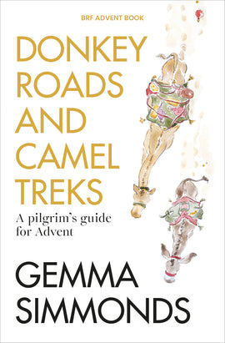
The cover sets the tone for this Advent book. We are taken on a meandering journey towards Christmas and, as each day unfolds, we find ourselves drawn more deeply into familiar yet unexplored territory. Gemma Simmonds has a unique talent to hold our attention with her opening sentences, and we are compelled to read onwards to see what will unfold. Her wit is woven into situations which other Advent books lack, but alongside this attribute is a spirituality which brings us closer to God on our pilgrim journey. We are encouraged to share the pilgrimage with others, as group study is encouraged. There are weekly questions and prayer activities as well as thoughtful reflections or each day. These will help us to know one another in a closer way and to share insights and challenges that maybe we have not thought possible in the past.

No journey is smooth and uneventful. Gemma Simmonds takes us along rocky and dangerous tracks to bring us to oases of peace and tranquillity. Be prepared for the unexpected, but be assured – you will emerge transformed and ready to receive the Christ child afresh at Christmas,

Reviewed by BETTY TAYLOR

9
Advent Reflection
Christians sometimes feel rather uneasy, or even perplexed, about Advent. There is a sense that – while the commercial and secular world gets on with the business of indulging itself with parties, food, decorations and gifts – those of us who come to church every Sunday ought to have a more serious, more thoughtful time. Surely, it can be argued, Advent must be reflective, not full of indulgence.
Up to a point, perhaps. At this time of year, churches do share with the commercial world a sense of joyful expectation, although of course our joy is directed towards the coming of Christ into our world of pain rather than the anticipation of expensive gifts and having too much to eat and drink. Nonetheless, it is probably not a good idea if we are too condemnatory, or if we treat Advent as a strict penitential season, like Lent. There is a risk of becoming like the gloomy Puritans of Oliver Cromwell’s time, when Christmas was abolished altogether. The kingdom of heaven will not expand if we abolish feast days. We need to strike a balance so that Advent is about anticipatory celebration and joy, and also an opportunity to reflect on its spiritual significance.
It may help to recognise a three-fold aspect to the season: past, present and future. This is not an original thought. It was an idea first set out in detail by the 12th century theologian and pillar of monasticism, Bernard of Clairvaux. He noted that, in the first Advent, now about two thousand years ago, Christ came physically into our world. He took on human flesh, and human infirmities, and dwelt among us. This is Advent past. In Advent present, in 2025, Christians believe that Christ takes on – present tense – power and spirit in today’s messy world. And in Advent future, Jesus Christ will take on majesty and glory when he comes again.
Bible readings throughout Advent emphasise both the first and the third Advents, as described by Bernard. It is the present Advent, that is mysterious and sometimes difficult to recognise.

10
The Art of Christmas
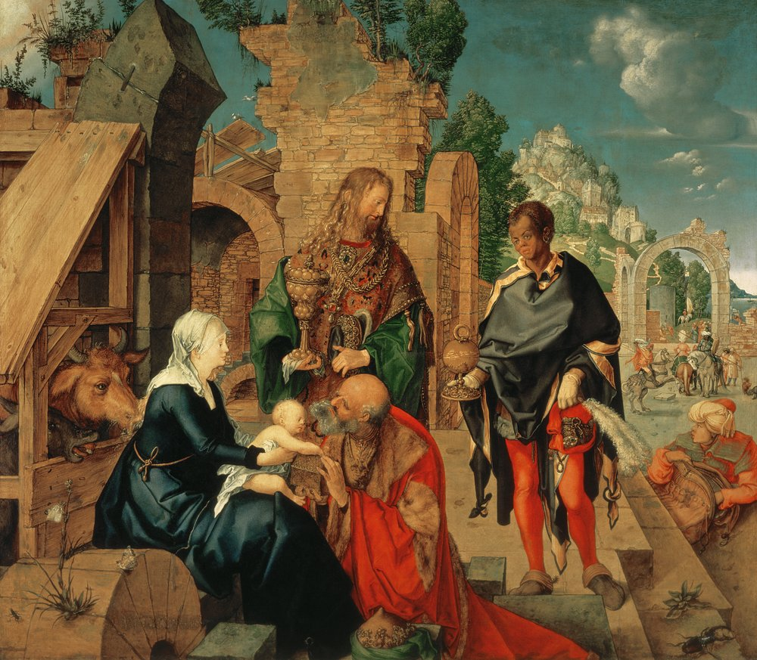
Albrecht Dürer(1471-1528): Adoration of the Magi

The Adoration of the Magi by Dürer is a panel painting, produced under commission for the famous church of the Schlosskirche at Wittenberg (where Martin Luther reputedly triggered the Reformation). It is one of Dürer’s best and most important works, and shows influence of his visits to Italy. Note that, by the 15th and 16th centuries, prominent artists had started to portray the visitors not as magi – that is, wise men or astrologers – but as richly

11
adorned kings. This emphasises the contrast between the poverty of the ramshackle dwelling for the holy family and the wealth of the visitors with their costly gifts. The young black monarch on the right of the portrait, who seems to be stepping forward with eagerness, emphasises that this is a visit from gentile rulers, and that Jesus will become a universal Saviour.

A poem for Christmas
Bethlehem Down by Bruce Blunt
When he is King we will give Him the King’s gifts,
Myrrh for its sweetness, and gold for a crown,
Beautiful robes,’ said the young girl to Joseph,
Fair with her first-born on Bethlehem Down.

Bethlehem Down is full of the starlight –
Winds for the spices, and stars for the gold,
Mary for sleep. And for lullaby music,
Songs of a shepherd by Bethlehem fold.

When he is King they will clothe him in grave-sheets,
Myrrh for embalming, and wood for a crown,
He that lies now in the white arms of Mary,
Sleeping so lightly on Bethlehem Down.

Here he has peace and a short while for dreaming,
Close-huddled oxen to keep Him from cold,
Mary for love, and for lullaby music,
Songs of a shepherd by Bethlehem fold.

12
Bethlehem Down is known as a hauntingly beautiful carol, although we seldom seem to hear it these days, unless it is sung by a choir. It was set to music by the composer Peter Warnock, but the words by the forgotten writer Bruce Blunt (1899-1957) may stand alone as a magnificent poetic commentary on the Christmas story.

Three of the four verses have a peaceful, pastoral quality – almost that of a folk song. With gentle tenderness they evoke the scene in Bethlehem, mentioning two of the gifts from the magi – gold and sweet smelling myrrh. This is the atmosphere we know so well from other carols – Away in a Manger or O little town of Bethlehem – all is calm and we stand in wonder at the birth of a holy child. But the third verse jolts us and reminds us, not of Christmas, but of Easter. There are no kingly robes and no crown, but grave-clothes and a crown of thorns. The sweet-smelling myrrh will be used for Christ’s embalming. This is the same message that we hear from Simeon to Mary at Candlemas on the fortieth day of Christmas: ‘This child is destined for the falling and the rising of many in Israel, and to be a sign that will be opposed…and a sword will pierce your own soul too’ (see Luke 2.34-35). The poignant words of Bethlehem Down bring us the message of Good Friday as well as Christmas Day.

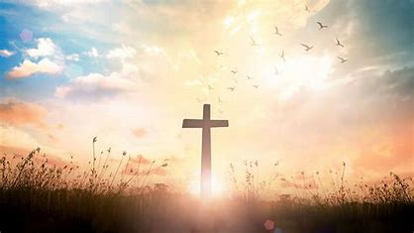

13
New Books for Christmas

The Grumpy Owl and the Joy of Christmas
Jonathan Maltz & Christopher Poch (illustrated by Jago)
Church House Publishing £4.99 pbk

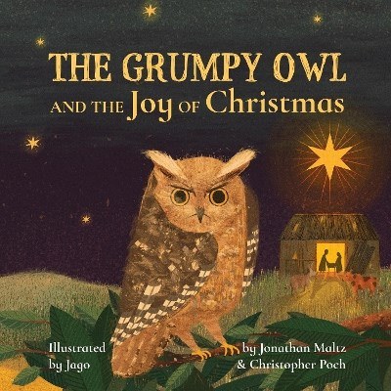

This delightful book will be an ideal present for very young children at Christmastide – prepare to intrigue your children and grandchildren with an imaginative ‘bird’s eye’ view of the traditional Christmas nativity story. The grumpy owl – solitary in his barn in Bethlehem – strongly resents the intrusion of two strangers, including a heavily pregnant young woman. He flies out to gain peace, only to meet noisy shepherds and then strange travellers from the east. After deciding he is better off in his barn, he arrives back to find a new-born baby, who seems to radiate peace and joy. The owl’s grumpiness vanishes as he gazes down on the child and perceives a spiritual answer to all his angst. A particular strength of this book is the excellent series of illustrations by award-winning artist Jago, especially his panoramic views of the nativity, which provide a kind of divine perspective. These help to emphasise that God indeed ‘came to earth as a tiny child’. I warmly recommend this bright and joyful stocking filler.

14

Twelve Joys of Christmas
Nicholas Papadopulos
Church House Publishing £0.99 pbk
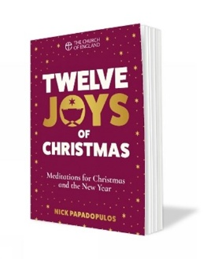

The attractiveness of this little book – designed I think to be given away at carol services and Christingles – is the way it merges the Christian message with the joys of traditional family celebrations over the festive season. It will appeal to children, parents and the older generations who perhaps long for the nostalgia of how Christmas used to be – that is, ‘low-tech’ fun. It is significant that neither television nor computer games feature within the twelve joys. Instead, the themes include a lot of different foods, going to the pantomime, brisk walks, crackers and the nostalgic smell of falling pine needles. The only ‘joy’ that I found slightly dubious, and I recognise my personal prejudice, was the ‘Christmas jumper’ – not for me, please! But each of the joys is adeptly linked to a short biblical theme and this produces a short reflection linked to an incarnational message. Let us hope and pray that these ideas make an impact and that many who ponder their message will find their faith strengthened or significantly renewed as we approach a new year. This book is written by the Dean of Salisbury, who has done an excellent job in presenting a series of serious religious messages within a joyful set of family celebrations. It could just be the way to draw people back to church life in 2026.

15
A thought for Christmas: the football match

Here is an extract from a diary. It was written on Christmas Day, 1914, by Lieutenant Johannes Niemann of the German Royal Saxony Regiment.
‘The mist was slow to clear and suddenly my orderly threw himself into my dugout to say that both the German and Scottish soldiers had come out of their trenches and were fraternising along the front. I grabbed my binoculars and looking cautiously over the parapet saw the incredible sight of our soldiers exchanging cigarettes, schnapps and chocolate with the enemy. Later a Scottish soldier appeared with a football which seemed to come from nowhere and a few minutes later a real football match got underway. The Scots marked their goalmouth with their strange caps and we did the same with ours. It was far from easy to play on the frozen ground, but we continued, keeping strictly to the rules despite the fact it only lasted an hour and that we had no referee. All the footballers, though they must have been very tired, played with huge enthusiasm. We Germans really roared when a gust of wind revealed that the Scots wore no drawers under their kilts – and hooted and whistled when we caught a glimpse of a posterior belonging to one of yesterday’s enemies. But after an hour’s play, when our commanding officer heard about it, he sent an order that we must put a stop to it. A little later we drifted back to our trenches and the fraternisation ended. The game finished with a score of three goals to two in favour of Fritz against Tommy.'
There was no overt description of religion in that extract. But there was a special spirit which had – in my view – religious overtones. From the misery of the trenches, men at war with each other exchanged gifts, and marked their rivalry with a friendly game. Imagine what might have been. Could peace have been declared there and then? It was too good to last, and commanding officers on both sides furiously ordered their men back behind lines.

16
What on earth possessed the combatants of WWI to climb out of
the trenches and exchange gifts?
The writer did not articulate it in this way, and I doubt that most of the soldiers themselves would have expressed it, but lying behind the narratives, almost lost within the drama, there was a sense of marking the incarnation of God. There was an unspoken recognition that Christmas represents the time when God came into the world – therefore we should respond. Through Jesus, God uniquely gained the experience of being human. And God signifies peace: the peace of God that passes all human understanding. Therefore, in the midst of war, make peace.

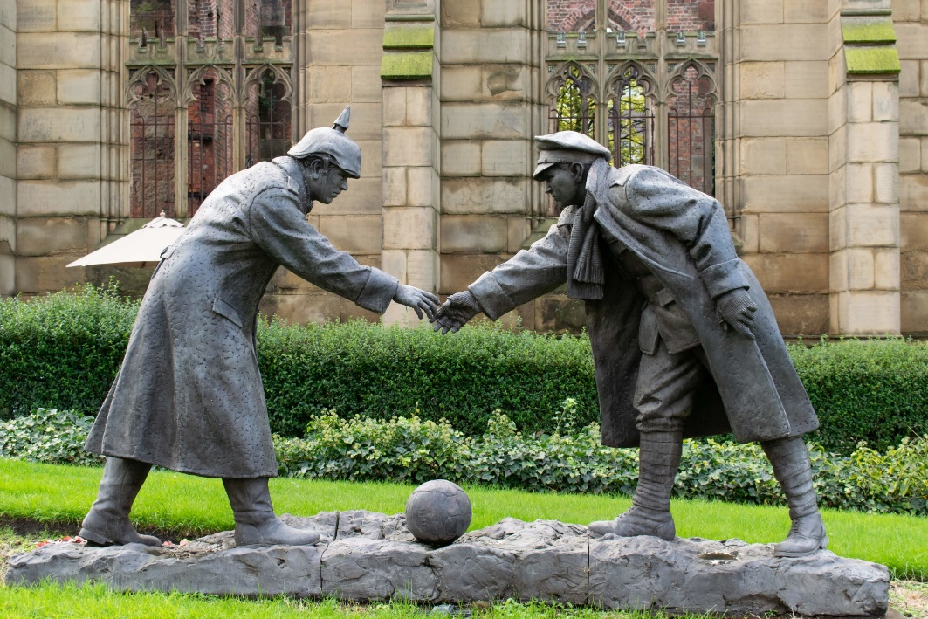

The Christmas Truce, 25 December 1914

17
Advent and Ecochurch 2025

As we enter a new church year, Liz Carr provides us with an important update

Our group of parishes are working towards a Gold ‘A Rocha’ Award for the benefice. Over the past few years, we have established our credentials and obtained silver and bronze awards in each of the churches. Since January 2025 there has been a new questionnaire survey with different questions to reflect the diversity of churches seeking awards. This means answering each of the five sections again for each church in the benefice; but as we want to ‘go for gold’ we also have to be able to prove that we are doing what we claim to be doing. Keeping our activities up to date on the online platform, A Church Near You is one way of doing this, and Amy, Rev Sally and others are working on this. Our buildings and worship in the benefice are already well on their way to gold status, but our work under the headings of community and lifestyle need to be considered in greater depth. As a benefice community, there are many who travel from church to church and who live in one parish but minster, in some way, in another. This is especially noticeable at Mundesley where the Community Larder, Warm Hub, Dementia Café, Café Church are used and run by people from across the benefice and beyond.
Over the Autumn, Rev Sally hosted ‘blue sky’ meetings at each church (with no agenda) to discuss what is wanted at each church and its individual charism. Some outcomes were obvious – for example, that Mundesley should be the centre for outreach and Bradfield should become a small ‘pilgrim place’ for quiet prayer every month (on the first of each month at noon). For others it is not so straightforward but, as a community, we are working on it. The Ecochurch team are also devising a policy and action plan for the group to direct our thoughts in a positive way. For example, we are

18
trying to work towards the recommendations as made by the Norfolk Wildlife Trust in the churchyard surveys undertaken last year to enhance the environment for our precious wildlife. Some churches are exploring the possibility of installing swift boxes in the church tower which will be of great joy to the local community.
On 23rd November 2025 we celebrated the 60th anniversary of the formation of the Trunch Group of Parishes with a special service at Paston, followed by a ‘bring and share lunch’ In our church calendar, that day celebrated Christ the King and the final Sunday of liturgical year C. We are about to start ‘year A’ and Advent with a group Advent carol service at Mundesley (3.00 pm on 30 November). Traditionally, Advent is a time for prayer and reflection and looking forward to the coming of baby Jesus at Christmas; but it could also be a time when we assess our lifestyles. There are many online Advent resources available from a variety of sources (including this issue of Connect). See for example our reviews of books for Advent and Christmas, including Twelve Joys of Christmas which has meditations for Christmas and New Year.

19
Advent and Christmas Services
Sunday 30 November – Advent Sunday
10.00 am Holy Communion, All Saints’ Church, Gimingham
3.00 pm Advent Carol Service, All Saints’ Church, Mundesley

Sunday 7 December – Second Sunday of Advent
10.00 am Holy Communion, All Saints’ Church, Mundesley

Sunday 14 December – Third Sunday of Advent
10.00 am Holy Communion, St Botolph’s Church, Trunch

Sunday 21 December – Fourth Sunday of Advent
10.00 am Holy Communion, St Peter’s and St Paul’s, Knapton

Wednesday 24 December – Christmas Eve
11.30 pm Midnight Communion, All Saints’ Church, Mundesley

Thursday 25 December – Christmas Day
10.00 am Holy Communion, St Botolph’s Church, Trunch

Sunday 28 December – First Sunday of Christmas
10.00 am Holy Communion (Book of Common Prayer), St Margaret’s Church, Paston

Sunday 4 January 2026 – Feast of the Epiphany
10.00 am Holy Communion, All Saints’ Church, Mundesley

See page 21 for other services, including Christmas Carol Services, Crib and Christingle services
20

Carol Services

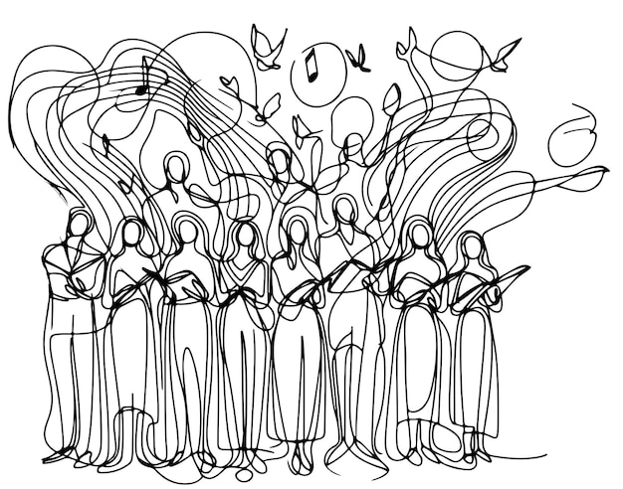

Bradfield Carol Service – Wednesday 17 December 2.00 pm

Gimingham and Café Church (at All Saints’ Gimingham)
Christingle – Wednesday 24 December 4.00 pm

Knapton Carol Service Sunday 21 December 6.30 pm

Mundesley ‘Living Nativity’ Sunday 21 December 4.00 pm

Trunch Crib Service – Wednesday 24 December 4.30 pm

-

Café Church meets at 11:00 in the Mundesley Community Rooms on Sunday Mornings (30 November, 7, 14 December)

The 10:00 Wednesday morning Holy Communion will be in the
Mundesley Community Hub on 3, 10, 17, 24, 31 December.

On the 1st of every month, St. Giles, Bradfield, hosts a silent prayer service beginning at 12 noon and lasting about 30 minutes

21
Other events during the Advent – Christmas season
For further details go to https://trunchgroup.org and https://trunchconcerts.com
Friday 28 November 7.00pm: Trunch and Swafield Cinema club will screen a live performance of The Fifth Step by David Ireland (National Theatre live) at St Nicholas Church, Swafield. Tickets £10 (01692 402624)

Sunday 7 December 4.00pm: Taverham Brass Band, All Saints’ Church, Mundesley. Tickets £10 | Please contact Bob: 07533 081292, for more information. Tickets on the door.

Saturday 13 December 7.30 pm Candlelit Christmas Concert – Sheringham and Cromer Choral Society, St Botolph’s Church, Trunch.
Tickets £15 (01692 402624)

22
Regular Events in the Mundesley Community Hub
Tuesday Warm Hub
You are warmly invited to join us at the Mundesley Community Hub to share a two course meal, enjoy the heating and use the space for whatever you would like. Be that card games, a catch up with friends (or meet new ones!), reading a book, pop along and see what Mundesley Warm Hub can do for you. Every Tuesday 15:30 til 17:00.
Wednesdays Memory Lane Café
We meet every other Wednesday between 1:30 and 4:00pm. Memory Lane Café is a warm, friendly, safe environment for people with dementia, their carers and anyone who would like to come along for a chat over tea, coffee and refreshments. We have music, activities and entertainment for all to enjoy. Memory Lane dementia Café is free for all to attend and you will be welcomed and looked after by our trained dementia friendly team of volunteers who would love to get to know you. For further information or if you would like to volunteer with us, please contact our team at MemoryLaneCafeMundesley@gmail.com
Next meeting 10 December; no meeting on 24 December2025.

Thursday Lunch Club
Come and join us at our Lunch club, all are welcome to partake in a 2 course meal, every third Thursday of the month. We open at 12 and lunch will be served at 12:30. We ask for a suggested donation of £5 a head.

Friday Community Cafe and Larder
Open every Friday morning with a Community Cafe from 9.00am and Community Larder from 10.00am, both until 12 noon. The community larder is open to all, and all food is donated via from Waitrose, Morrisons and Tesco. Anyone can add to the larder from their allotment/vegetable patch and anyone can take away food regardless of their circumstances. Our Community Cafe offers free tea or coffee, and a choice of wholesome food as well as good company. All welcome – pop in and be part of the community

23

Some Parish Contacts

Rector: Revd Dr Sally Myers (Sally)

Canon John Carr 01263 720788 carr.ide@btinternet.com

Revd Jenny Lodge 01263 649020
(working days; Tue, Wed, Fri, Sun)

Safeguarding Officer: Allison Jackson 01263 720826
allisonjackson0756@hotmail.com

Editors of Connect: Amy and Keith Shepherd (amy@trunchgroup.org)
and Dr Peter Clough (clough868@btinternet.com)


24

